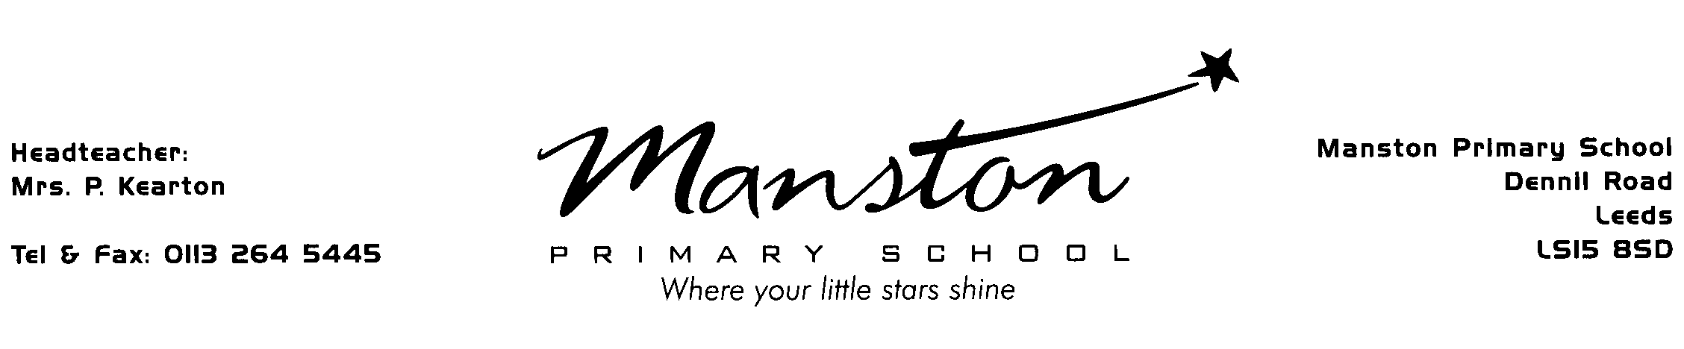

Administration of Medication at School
Only for medication that requires four doses a day

I give permission for a member of staff to administer prescribed medication for my child.

I take full responsibility for any medication administered by staff on my behalf to the dosage and times I have listed below.

Childs name : _____________________ (Year)____

Name of parent/carer in capitals:__________________________

Signature : ______________________ (parent/carer)

Date : ________________________

NAME OF MEDICATION | DOSAGE (e.g. 1 x 5ml – 1 tablet etc)
TIME TO BE GIVEN:

Leeds City Council will not be held liable for any injury or death arising directly or indirectly from the administration of prescribed medication, other than through the council’s negligence.

