***Manston Primary School***

**A Quick Guide to Deafness and Hearing Impairment**

# What are the types of hearing loss?

* Sensorineural deafness is a hearing loss in the inner ear. It is permanent.
* Conductive deafness means that sound can't pass efficiently through the ear.
* Glue ear is a very common condition, especially in pre-school children.
* Conductive deafness is usually temporary, but it can be permanent in some cases.
* It's possible for children to have a combination of sensorineural and conductive deafness. This is known as mixed deafness.

Deafness in one ear only is known as unilateral deafness. Deafness in both ears is known as bilateral deafness. There are different types of amplification’s that enhance deaf children’s residual hearing. Most deaf children can hear some sounds at certain frequencies and loudness, and with the use of audiological technology they are often able to hear more sounds.

<https://www.ndcs.org.uk/information-and-support/childhood-deafness>

The level of a child’s deafness can be described in terms of their decibel (dB) hearing level, or by the terms ‘mild’, ‘moderate’, ‘severe’ or ‘profound’.

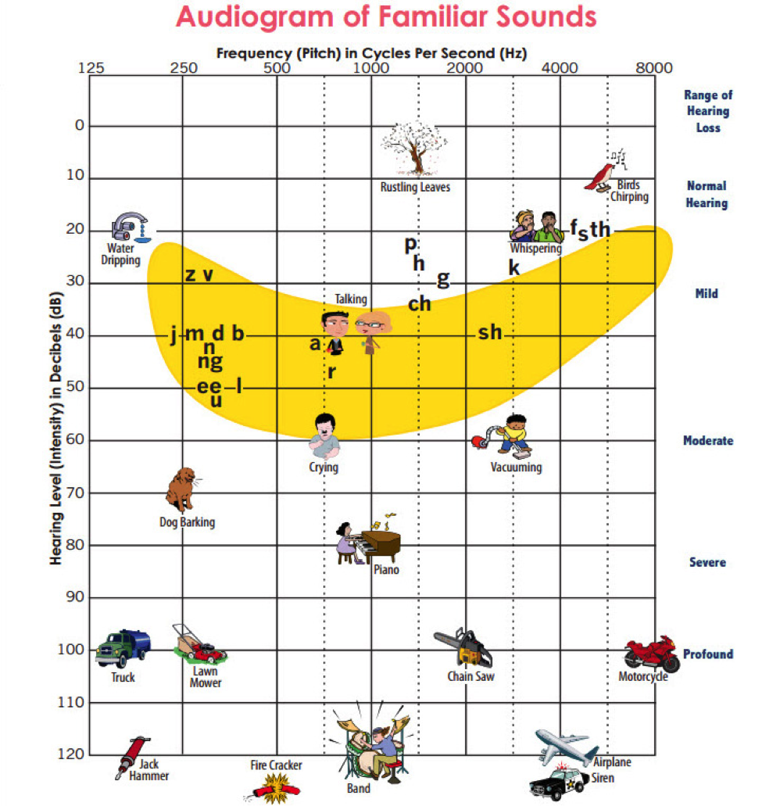Based on British Society of Audiology definitions of hearing loss, this is the decibel hearing level range each of these terms refer to:

* mild (21–40 dB)
* moderate (41–70 dB)
* severe (71–95 dB)
* profound (95 dB)

# Implications for a pupil

* A Deaf child may become frustrated if they cannot communicate effectively or if they do not understand what is happening around them because they cannot hear clearly.
* They may not hear all the individual sounds in a word. It is common for them to leave out word endings like ‘s’ or ‘ed’.
* They may have a limited vocabulary because they cannot hear conversations going on around them (lack of incidental learning).
* They may struggle when one word has several meanings e.g., Catch a cold, catch a ball, the catch on the gate.
* It may be challenging for a deaf child to learn appropriate social behaviour incidentally.
* Communicating effectively with hearing peers can be frustrating, this could limit the initiation of conversations and have implications of feeling fully included in large groups.
* They may find it difficult to express their feelings and emotions and subsequently the development of confidence and self-esteem could be restricted.

# How to help – top tips

1. Make things as visual as possible.
2. Write key words on the board. Keep them visible throughout the lesson.
3. Use the internet for pictures/videos so they know what you’re talking about.
4. Don’t give out information or talk to the whole group when they’re supposed to be copying from a board. They can’t watch the signer and write.
5. Scaffold and support writing.
6. Use subtitled videos
7. Set homework with a clear explanation before the end of the lesson.
8. Are you testing English ability or subject knowledge? Can the assessment reflect this?

# Further advice and support

**Useful Websites:**

Further information about hearing loss can be found on the NDCS website [www.ndcs.org.uk](http://www.ndcs.org.uk/)

The Leeds Society for Deaf and Blind People: [www.lsdbp.org](http://www.lsdbp.org)

**Reading:**

Knoors, H. and Marschark M., 2019 [Evidence-based practices in deaf Education](https://leeds.primo.exlibrisgroup.com/discovery/search?query=any,contains,991002984959705181&tab=AlmostEverything&search_scope=My_Inst_CI_not_ebsco&vid=44LEE_INST:VU1&offset=0).

Knoors, H. and Marschark M., 2015 [Educating Deaf Learners, Creating a Global Evidence Base](https://leeds.primo.exlibrisgroup.com/discovery/search?query=any,contains,991010074229705181&tab=AlmostEverything&search_scope=My_Inst_CI_not_ebsco&vid=44LEE_INST:VU1&offset=0).

Marschark, M. Lampropoulou, V. and Skordilis, E. 2016 [Diversity in Deaf Education](https://leeds.primo.exlibrisgroup.com/discovery/search?query=any,contains,991013538909705181&tab=AlmostEverything&search_scope=My_Inst_CI_not_ebsco&vid=44LEE_INST:VU1&offset=0).