**Manston Primary**

**Music Development Plan - 2024/2025**

School address

99 Basic way  
leeds  
LS1 1sl

Headteacher: Mr J Clay

Music Lead Teacher: Miss L Racster

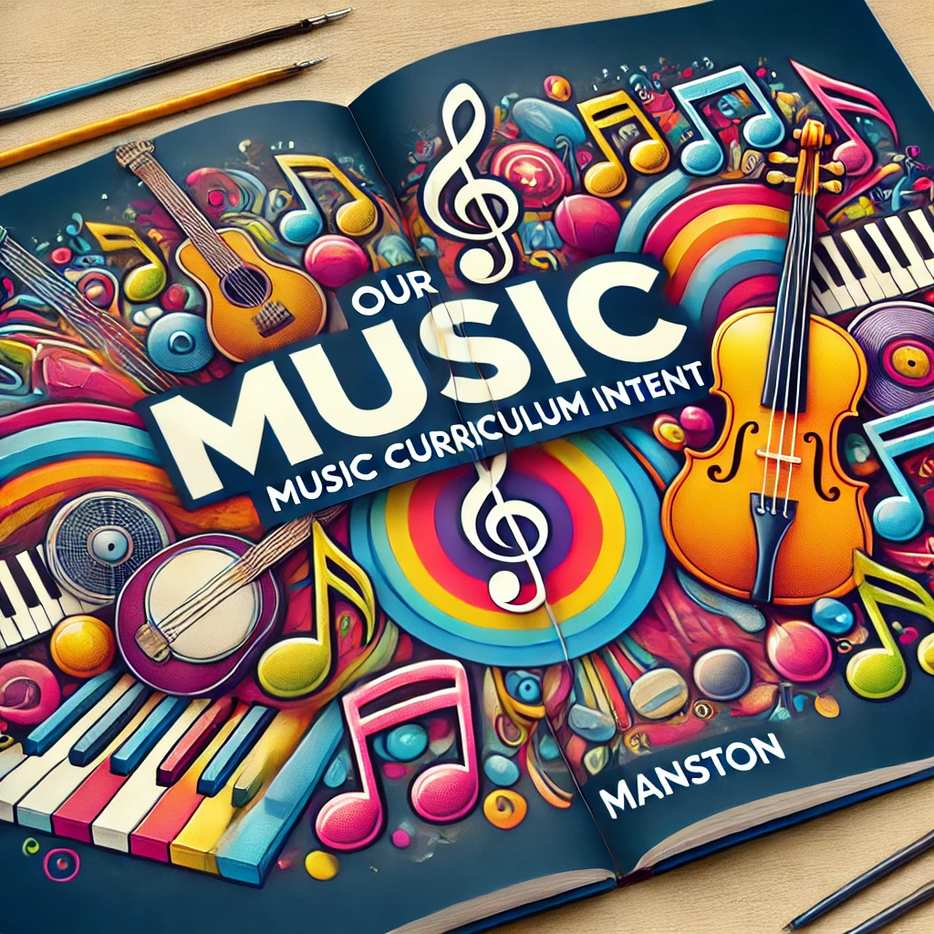

We believe that music is a unique and powerful form of communication that has the ability to reach out to anyone.  Music can take pupils through time, to different places and through emotional journeys and can change the way they think, feel and act. We feel a quality musical education promotes creativity and personal expression as well as development and reflection to prepare our pupils for life in modern Britain. We aim to ensure our curriculum is accessible to all and encourages a love of music. Through this curriculum, our pupils are able to discover their aptitudes, abilities and preferences, sample a range of music, instruments and styles

 and make choices about how to get involved in lifelong music learning.

We follow the National Curriculum for Music, using the Charanga Music School programme as well as whole class instrumental teaching and use of Bamboo Tamboos and other percussion instruments.

Along with the lessons taught in class, the whole school comes together once a week for singing assembly, which is a chance to perform together and further build upon singing skills taught in each year group. We also have an enthusiastic school choir who help develop community links by performing at different events locally.

We understand the importance of children experiencing quality live music and being exposed to a variety of styles and instruments so each year we have a different group of musicians come in to school to perform to the whole school and demonstrate different musical genres with a range of instruments.

|  |  |  |  |
| --- | --- | --- | --- |
| 1 – Not yet in place | 2 - Emerging | 3 - Established | 4 - Embedded |
| *Prioritise for support and development* | *Further development and support required. Not yet sure of impact on outcomes* | *Effective in producing good outcomes. Some ongoing support may be required to maintain or further improve provision* | *Highly effective in producing excellent outcomes.* |

|  |  |  |  |
| --- | --- | --- | --- |
| Area | Category | Description | Comments |
| Curriculum Music | Timetabling | 1 - Not all classes receive a regular music lesson each week | 3 Churanga curriculum followed for whole school |
| 2 - Music lessons are scheduled but not always delivered regularly |
| 3 - There are weekly timetabled curriculum music lessons in all years |
| 4 – There are weekly timetabled curriculum music lessons in all years plus other provision which totals 1 hour per week for all children (can include singing assemblies etc) |
| Curriculum design | 1 - Musical activity takes place in some or all classes but not tied to a formal school-wide curriculum | 2 progression over the years is in place due to the Churanga scheme that provides this and the build of the Ukulele teaching over time in UKS2. However, staff development would increase the understanding of this. |
| 2 – There is a whole school curriculum in place for music but progression over the years is not clear or well understood |
| 3 - There is a whole school curriculum in place for music which covers all parts of the National Curriculum. It is clear how each year builds on the previous years and lays a foundation for what the children will learn next |
| 4 - There is a whole school curriculum in place which clearly maps progress and skills across the key stages. Teaching staff are aware of how their year fits into the bigger picture. Additional aspects are embedded into the planning such as whole class instrumental music, school performances and special musical events |
| Assessment | 1 - No or very little formal assessment takes place in music. There is limited capacity and/or expertise for assessing musical progress | 3, Assessment for learning is used in lessons, data on pupils' attainment is gathered annually, specialist teaching (Ukulele) allows for expert feedback). |
| 2 – Some assessment and recording of progress is taking place in some classes. Quality of verbal feedback in lessons varies widely and further support is needed |
| 3 – Assessment and progress is documented in all year groups and verbal feedback in lessons is of good quality |
| 4 - Progress is clearly recorded using a variety of methods and ML works closely with class teachers to monitor and support quality of feedback in lessons. There are opportunities for pupils to self and peer assess their work planned into lessons |
| Quality of teaching | 1 - The teachers delivering music are mostly lacking confidence and expertise in the subject | 2- Staff have different levels of CPD and Confidence levels. i.e. ECT teacher and former Secondary Music teacher on staff. |
| 2 - Music teaching is of a mixed standard, there is still a need for further CPD and support. |
| 3 - Music teaching is mostly or all good quality throughout school |
| 4 - Music teaching is consistently good quality and is regularly monitored and supported |
| EYFS music | 1 - It is uncertain how much music takes place in Nursery/Reception classes or whether it is of consistently good quality | 3 Pupils enjoy singing and music regularly, topic links are made often with instruments used in PE and areas of provision. |
| 2 - Music is regularly planned in to EYFS though some CPD and support would still be beneficial |
| 3 - Music teaching and singing leading is of good quality in EYFS. Regular lessons include appropriate songs and activities and the children clearly make progress |
| 4 - Music is an integral and essential daily part of EYFS life. Songs and activities are appropriate to developing voices and carefully chosen to support early progress |
| Whole class instrumental provision | Whole class | 1 - No whole class instrumental provision is currently in place | 3 –Pupils in Years 4-6 receive 1 year of Uke over 3 years. Other classes use musical instruments such as chime bars, chair drums, mixed percussion.  Year 6 perform at end of their tuition equivalent to 1 year of weekly lessons. |
| 2 - Children are given a ‘taster’ on one or more instruments in whole class lessons which is less than one year in duration |
| 3 - Children are given a full year to learn an instrument and as such develop basic skills and knowledge securely in that time. There are opportunities during the year for the children to perform to others |
| 4 - Whole class learning is fully integrated into the wider music curriculum and is deliberately placed for pupil progression. The instrument/s are also selected for progression and quality of delivery is consistently good. Some children choose to carry on with that instrument (or a related instrument) at the end of the year in whole class follow on or small group lessons. |
| Singing | School / KS / Year group singing | 1 - Children rarely or never sing together as part of a larger group | 3 – timetabled weekly for whole school |
| 2 - Children sing together occasionally at some points during the year (e.g. Christmas, Harvest) |
| 3 - Children sing together all or most weeks as part of a singing assembly or similar |
| 4 - Regular singing assemblies are led by a specialist. Singing is an important and integral part of curriculum lessons, delivered by confident teachers skilled in delivering healthy singing |
| Choirs | 1 - There are currently no school choirs taking place regularly | 2 - 3 – Autumn & Summer Choirs are formed throughout the year. |
| 2 - A school choir forms for special occasions only (e.g. Christmas, Young Voices) |
| 3 - There is at least one school choir which meets regularly led by a skilled teacher |
| 4 - There are one or more school choirs, led by skilled singing leaders which have opportunities to perform regularly and/or take part in wider community events |
| Instrumental and vocal lessons | Tuition | 1 - There are currently no opportunities for children to learn to play an instrument in school | 2 – Guitar lessons offered during / after school through we create music. These groups perform in school. |
| 2 - Children have the opportunity to learn an instrument in at least one family of instruments. There are occasional opportunities for children to perform on their instruments |
| 3 - Children have the opportunity to learn to play an instrument in two or more musical families (e.g. woodwind and guitar) There is a healthy uptake each year of students wanting to learn to play |
| 4 - There are opportunities for children to learn an instrument in various instrumental families with regular opportunities to perform to others. School regularly engages and plans with their instrumental tutors allowing for a consistent approach to music provision |
| Whole class follow on | 1 - There is currently no whole class instrumental teaching taking place in school | 2 No timetabled slots for this in primary curriculum |
| 2 - There are currently no opportunities for children to continue learning an instrument they have started in whole class teaching |
| 3 - There are opportunities for children to continue learning the instrument (or a closely related instrument) after whole class lessons have finished. |
| 4 - There are opportunities for children to continue learning the instrument (or a closely related instrument) after whole class lessons have finished and a good number of children choose to do this, ultimately progressing on to small group lessons. |
| Ensembles | 1 - There are currently no instrumental ensembles in school | 1 |
| 2 - Children learning some instruments are encouraged to join ensembles and signposted to music centres or CLYM groups |
| 3 - There is a school ensemble which allows some children to play together regularly in a group |
| 4 - Any child learning any instrument in school has the chance to play that instrument in an ensemble. There are regular performing opportunities with the group. Routes of progression for children including music centres and CLYM are signposted as appropriate |
| Inclusion | Inclusion | 1 - There are no provisions in place to support less affluent families. There is little adaptation in music lessons for children with additional needs or varying ability and there are limited opportunities to experience the music of different cultures | 2 – no need to adapt for current cohort of pupils. Occasional musical experiences from other culture ad hoc. |
| 2 - There is some provision in curriculum music lessons for children with additional needs or disabilities. Occasional opportunities to experience music from different cultures and traditions |
| 3 - School applies for LMEP bursaries or finds other ways to support children from low income backgrounds to learn an instrument.  Curriculum and instrumental lessons are planned to cater for children with varying needs and abilities. Pupils have opportunities to listen to and engage with music from different cultures and traditions |
| 4 - All staff (including visiting staff) are fully aware of any relevant additional needs in their classes. Lessons are well differentiated to cover all needs and abilities. Children are sensitively guided to learning an appropriate instrument for their specific needs Pupils have opportunities to listen to and engage with music from a wide variety of different cultures, traditions and eras |
| Wider involvement | Hub participation | 1 - The school generally don’t engage with the Leeds music hub (LMEP) or other partner organisations in music | 2 – Local events, virtual, attendance at lead meetings and CPD  School have previously taken part in Little sing, Leeds Arena music event and The Big Sing. |
| 2 - The school engages with LMEP or other partner with occasional participation in local events |
| 3 - There is a good level of engagement with LMEP and Music Connect with annual participation in local events |
| 4 - The school has strong partnerships with LMEP, Music Connect and/or other organisations with regular participation in multiple local events and concerts |
| CPD | 1 - There is little capacity within school for the music lead or other staff to engage with music CPD | 2  Music lead attends network meetings. |
| 2 - Music lead has occasional opportunities to access CPD, other staff only rarely |
| 3 - Music Lead regularly accesses CPD in music teaching and has opportunities to pass this on to other staff in school |
| 4 - Music Lead and other staff in school access CPD in music. Music Lead has a good understanding of where gaps lie in staff knowledge and works to address those over time |
| Links with other schools | 1 - There are currently no musical links with other schools | 2 |
| 2 - Occasional links are made with other local schools for musical events or activities |
| 3 - Some links are made with peer schools, other MAT schools, religious school networks or cluster networks. Occasional musical events may take place within these communities or resources and expertise are shared. There are some transition arrangements in music with the local secondary schools |
| 4 - Strong links are made with other schools with opportunities to share resources, expertise and to organise events. There are strong links made to local secondary schools for Y6 transition. |
| Live music | 1 - There are currently no opportunities for children to experience and enjoy live music | 2 |
| 2 - There are occasional opportunities for some children to experience live music either on a trip or from visiting musicians |
| 3 - All children have opportunity to experience live music over the course of the school year. |
| 4 - All children have the opportunity to experience live music from a range of musicians which reflects the diversity of music in our world. Live music is integrated into the school’s curriculum with wider opportunities to explore the genres |



|  |  |
| --- | --- |
| **MUSIC DEVELOPMENT PLAN** | |
| Key components | *List the key components that will make up the music provision in your school. The list below is an example and should be adapted for your school.*  Music curriculum taught by class teachers, including use of music technology across school  Classroom instrumental teaching by a specialist of Ukuleles across Years 4,5 and 6 for 1 term each academic year.  Private Guitar Lessons weekly during / after school.  Links with external music organisations  Pupil Premium student engagement  Music CPD  Choirs/ensembles  Music Club offered by staff for EYFS/KS1  Whole school singing assemblies/ hymn practice  Performance opportunities including sharing with parents - Crossgates Christmas lights etc...  Musical engagement with feeder secondary schools  Additional funding from hub/charities/fundraising  Musical theatre experiences |
| Communications | The school music development plans and our long term plans for the music curriculum will be uploaded to the school website.  Performances and experiences will be shared on school newsletter with parents invited as possible |
| Budget, materials and staffing | *How do we resource the provision –*  1 x We create music teacher for Ukes and Guitar sessions  School budget for resources such as additional instruments, subscriptions and other equipment |

|  |  |  |  |  |
| --- | --- | --- | --- | --- |
| **Key Areas development plan 2024/2025** | | | | |
| Target | Area for development  (Intent) | Actions ( Implementation) | Date to be completed by | Evaluation  ( Impact) |
|  | Staff CPD – progression and skills | * Staff meeting focusing CPD on curriculum progression and use of resources. | Summer 2025 |  |
|  | To develop more opportunities for pupils to experience live music from a range of genres | * Meet with high school music lead to investigate live music to be delivered by high school pupils. * Pupils attend shows at local secondary * More musical performances that are diverse in instrument and culture. * Whole school invited to class music performances * Choir to continue to perform in assemblies - 3 x a year | Summer 2025 |  |
|  | Classes / groups performing – Singing assembly slot. | * Choir * Guitars * Ukes * Class sharing. | Summer 2025 |  |