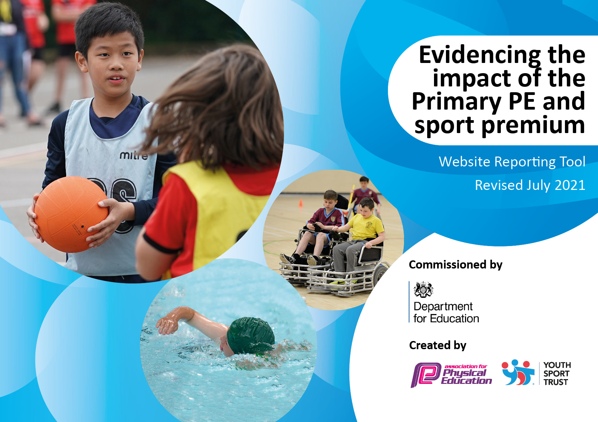

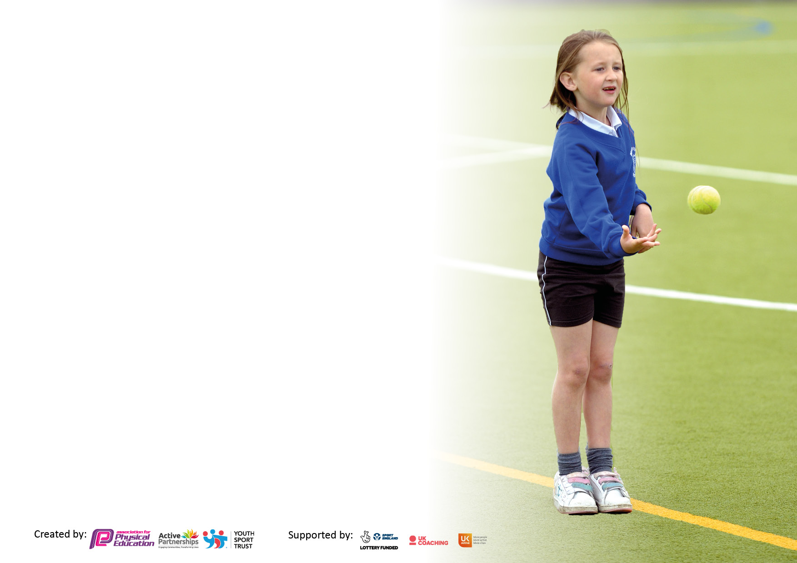

It is important that your grant is used effectively and based on school need. The [Education Inspection Framework](https://assets.publishing.service.gov.uk/government/uploads/system/uploads/attachment_data/file/843108/School_inspection_handbook_-_section_5.pdf) makes clear there will be a focus on **‘whether leaders and those responsible for governors all understand their respective roles and perform these in a way that enhances the effectiveness of the school’**.

Under the [Quality of Education](https://assets.publishing.service.gov.uk/government/uploads/system/uploads/attachment_data/file/843108/School_inspection_handbook_-_section_5.pdf) Ofsted inspectors consider:

**Intent** - Curriculum design, coverage and appropriateness

**Implementation** - Curriculum delivery, Teaching (pedagogy) and Assessment

**Impact** - Attainment and progress

To assist schools with common transferable language this template has been developed to utilise the same three headings which should make your plans easily transferable between working documents.

Schools must use the funding to make **additional and sustainable** improvements to the quality of Physical Education, School Sport and Physical Activity (PESSPA) they offer. This means that you should use the Primary PE and sport premium to:

* Develop or add to the PESSPA activities that your school already offer
* Build capacity and capability within the school to ensure that improvements made now will benefit pupils joining the school in future years
* The Primary PE and sport premium should not be used to fund capital spend projects; the school’s budget should fund these.

Pleasevisit[gov.uk](https://www.gov.uk/guidance/pe-and-sport-premium-for-primary-schools)fortherevisedDfEguidanceincludingthe5keyindicatorsacrosswhichschoolsshoulddemonstrate animprovement.Thisdocumentwillhelpyoutoreviewyourprovisionandtoreportyourspend.DfEencouragesschools to use this template as an effective way of meeting the reporting requirements of the Primary PE and sport premium.

We recommend you start by reflecting on the impact of current provision and reviewing the previous spend.

Schools are required to [publish details](https://www.gov.uk/guidance/what-maintained-schools-must-publish-online#pe-and-sport-premium-for-primary-schools) of how they spend this funding, including any under-spend from 2019/2020, as well as on the impact it has on pupils’ PE and sport participation and attainment. **All funding must be spent by 31st July 2023.**

We recommend regularly updating the table and publishing it on your website throughout the year. This evidences your ongoing self-evaluation of how you are using the funding to secure maximum, sustainable impact. Final copy must be posted on your website by the end of the academic year and no later than the 31st July 2021. To see an example of how to complete the table please click [HERE](http://www.afpe.org.uk/physical-education/wp-content/uploads/afPE-Example-Template-Indicator-2018-Final.pdf).



**Details with regard to funding**

Please complete the table below.

|  |  |
| --- | --- |
| Total amount carried over from 2022/23 | £0 |
| Total amount allocated for 2023/24 | £17,770 |
| How much (if any) do you intend to carry over from this total fund into 2023/24 | £0 |
| Total amount allocated for 2024/25 | £17,700 |
| Total amount of funding for 2024/25. To be spent and reported on by 31st July 2024. | £17,770 |

**Swimming Data**

Please report on your Swimming Data below.

|  |  |
| --- | --- |
| Meeting national curriculum requirements for swimming and water safety.  N.B. Complete this section to your best ability. For example you might have practised safe self-rescue techniques on dry land which you can then transfer to the pool when school swimming restarts.  **Due to exceptional circumstances priority should be given to ensuring that pupils can perform safe self rescue even if they do not fully meet the first two requirements of the NC programme of study** | We complete 3 water safety sessions per year at the pool (1 per term) and simulate this in class.  School Assemblies each year also focus on the dangers of water including canals rivers and seaside. |
| What percentage of your current Year 6 cohort swim competently, confidently and proficiently over a distance of at least 25 metres?  **N.B.** Even though your pupils may swim in another year please report on their attainment on leaving primary school at the end of the summer term 2023.  Please see note above | Y6 2023 – (16 pupils 25m + 16 pupils-15m ,9 pupils - 10m) |
| What percentage of your current Year 6 cohort use a range of strokes effectively [for example, front crawl, backstroke and breaststroke]?  Please see note above | 28 pupils |
| **What percentage of your current Year 6 cohort perform safe self-rescue in different water-based situations?** | 100% |
| Schools can choose to use the Primary PE and sport premium to provide additional provision for swimming but this must be for activity **over and above** the national curriculum requirements. Have you used it in this way? | Yes |

|  |
| --- |
| **Subject Intent** |
| We aim for all pupils to be physically literate, with the knowledge, skills and motivation necessary to support them in maintaining a healthy lifestyle and a lifelong participation in physical activity and sport.  Pupils learn how to think in different ways to suit a wide variety of creative, competitive and challenging activities. They learn how to plan, perform and evaluate actions, ideas and performances to improve their quality and effectiveness. Through this process, our pupils are able to discover their aptitudes, abilities and preferences and make choices about how to get involved in lifelong physical activity. To ensure our pupils can all swim we take them swimming in Year 3 and 4 for the full year with additional intensive sessions delivered to older pupils who still need this vital lifesaving skill.  Physical education is an essential part of children’s well-being and health and is an integral part of our school day. Our pupils not only take part in twice weekly Physical Education and Sports lessons, they also develop their fitness and stamina at playtimes and through addition sessions including, yoga and the Manston Mile sessions. We also encourage our pupils to take part in sport clubs after school and clubs in the local community by celebrating and promoting participation and achievements. |

**Action Plan and Budget Tracking**

Capture your intended annual spend against the 5 key indicators. Clarify the success criteria and evidence of impact that you intend to measure to evaluate for pupils today and for the future.

|  |  |  |  |  |
| --- | --- | --- | --- | --- |
| **Academic Year:** 2024/5 | **Total fund allocated:** | £11,250(63.56% of fund allocation) | |  |
| **Key indicator 1:** The engagement of all pupils in regular physical activity – Chief Medical Officers guidelines recommend that primary school pupils undertake at least 30 minutes of physical activity a day in school | | | | |
| **Intent** | **Implementation** | | **Impact** |  |
| Your school focus should be clear what you want the pupils to know and be able to do and about  what they need to learn and to  consolidate through practice: | Make sure your actions to achieve are linked to your intentions: | Funding allocated: | Evidence of impact: what do pupils now know and what can they now do? What has changed?: | Sustainability and suggested next steps: |
| * To give all pupils the chance to take part in structured and developmental physical activity.   Pupils learn how to think in different ways to suit a wide variety of creative, competitive and challenging activities. They learn how to plan, perform and evaluate actions, ideas and performances to improve their quality and effectiveness. Through this process, our pupils are able to discover their aptitudes, abilities and preferences and make choices about how to get involved in lifelong physical activity. | * ACE coaches for all pupils at lunch times to: provide a wide range of activities to try and develop their skills – this has then linked to some pupil representing school in tournaments * Scrap Sheds – The installation of 3 scrap sheds, training for staff and ongoing replacement offer pupils a wide variety of ways to be physical active while at play * Ensure that school has the equipment and resources for pupils to stay active in lessons and during play. * Fund additional opportunities for pupils to attend a residential through ACE coaches subsidised by school and Active holidays | £4,550  £3,700  £2,000  £,1000 | * ACE Impact: Pupils of all ages play and join in with a range of physical activity daily (dodgeball, dance, basket ball…); pupils try new sports and are able to do so in a fun and supportive manner; pupils who have frequently attended sessions for one sport have then been picked to represent the school in this area. * Scrap Shed Impact: Pupils of all ages use the shed contents for imaginative physical play; lessons on bridges, pirates and other topics have made use the resources to bring learning to life and make it physical; whole staff training showed staff the importance of physical play using the sheds resources and how to encourage this. * Lessons have required resources to ensure full participation. Playtimes offer a variety of resources to pupils to help them play active games. Fixed PE apparatus (external and internal) is maintained and | * ACE - To continue with ACE coaches at lunch times and increase the school’s participation in ACE interschool competitions. * Scrap Shed – To continue to restock the sheds with new equipment and update staff training as needed. |
| **Key indicator 2:** The profile of PESSPA being raised across the school as a tool for whole school improvement | | | | Percentage of total allocation: |
| 5.656% |
| **Intent** | **Implementation** | | **Impact** | £1000 |
| Your school focus should be clear what you want the pupils to know and be able to do and about  what they need to learn and to  consolidate through practice: | Make sure your actions to achieve are linked to your intentions: | Funding allocated: | Evidence of impact: what do pupils now know and what can they now do? What has changed?: | Sustainability and suggested next steps: |
| * To keep the profile or PE and sports high within school   Physical education is an essential part of children’s well-being and health and is an integral part of our school day. Our pupils not only take part in twice weekly Physical Education and Sports lessons, they also develop their fitness and stamina in Wake and Shake, yoga and Manston Mile sessions. We also encourage our pupils to take part in sport clubs after school and clubs in the local community by celebrating and promoting participation and achievements. | * Offering a range of after school and in school opportunities for pupils to take part in, including: Football club, yoga, badminton club and others * Celebrating in school and external sporting participation and success in whole school assembly * Actively engaging with local sports clubs to host taster sessions and promote clubs to pupils and parents including – LUFC events, Whitkirk Tennis club, Whinmoor warrior’s rugby local swimming lessons and many more. | £1000 | * High attendance at all sports clubs offered * Frequent celebration in school assemblies and newsletters of pupil’s achievements in school and outside of school. | * Review and increase the variety of sporting clubs the school offers. Consider the use of sports premium funding to widen the offer. |

|  |  |  |  |  |
| --- | --- | --- | --- | --- |
| **Key indicator 3:** Increased confidence, knowledge and skills of all staff in teaching PE and sport | | | | Percentage of total allocation: |
| 9.68% |
| **Intent** | **Implementation** | | **Impact** | £1712.50 |
| Your school focus should be clear | Make sure your actions to | Funding | Evidence of impact: what do | Sustainability and suggested |
| what you want the pupils to know | achieve are linked to your | allocated: | pupils now know and what | next steps: |
| and be able to do and about | intentions: |  | can they now do? What has |  |
| what they need to learn and to |  |  | changed?: |  |
| consolidate through practice: |  |  |  |  |
| * Our aim is for QFTL in all aspects of PE and Sport in our school. | * Subscription of PE scheme of work – Get Set 4 PE * Well Leeds - Leeds Rhinos SLA | £412.50 (£1237.50 3 year subscription)  £1300 | * Get for 4 PE – Scheme of work to be implemented from September 2022 * PE lead in updated on all things PE by 1:1 session and half term briefings. | * Review of implementation/impact through monitoring. * Engagement with Well Leeds Increased level of PE lead support and sports opportunities for pupils. |
| **Key indicator 4:** Broader experience of a range of sports and activities offered to all pupils | | | | Percentage of total allocation: |
| 35.25% |
| **Intent** | **Implementation** | | **Impact** | £6,240 |
| Your school focus should be clear | Make sure your actions to | Funding | Evidence of impact: what do | Sustainability and suggested |
| what you want the pupils to know | achieve are linked to your | allocated: | pupils now know and what | next steps: |
| and be able to do and about | intentions: |  | can they now do? What has |  |
| what they need to learn and to |  |  | changed?: |  |
| consolidate through practice: |  |  |  |  |
| * We aim for all pupils to leave Manston with water confidence and being able to swim.   To ensure our pupils can all swim we take them swimming in Year 3 and 4 for the full year with additional intensive sessions delivered to older pupils who still need this vital lifesaving skill.  Additional achievements: KS2 pupils completed Brownlee Triathlon, Y6 dodge baller competition runners up | * Pupils in Years 3 and 4 receive swimming lessons for the whole year. * Additional swimming teacher for both year groups all year. | * £6,240   (££12,480 full cost) | * Improved swimming outcomes and water confidence for all pupils. Evidenced by above swimming data and schools own tracking of pupils swimming abilities. | * Continuation of additional swimming sessions and intensive swimming sessions for all pupils * Explore how to promote further engagement from parents and cares of disadvantaged pupils with additional free intensive swimming sessions. (Some uptake in previous years but no solid data shared) |

|  |  |  |  |  |
| --- | --- | --- | --- | --- |
| **Key indicator 5:** Increased participation in competitive sport | | | | Percentage of total allocation: |
| %8.47 |
| **Intent** | **Implementation** | | **Impact** | £1500 |
| Your school focus should be clear | Make sure your actions to | Funding | Evidence of impact: what do | Sustainability and suggested |
| what you want the pupils to know | achieve are linked to your | allocated: | pupils now know and what | next steps: |
| and be able to do and about | intentions: |  | can they now do? What has |  |
| what they need to learn and to |  |  | changed? |  |
| consolidate through practice: |  |  |  |  |
| * Encourage pupils to take up competitive sport in and out of school   Pupils learn how to think in different ways to suit a wide variety of creative, competitive and challenging activities. They learn how to plan, perform and evaluate actions, ideas and performances to improve their quality and effectiveness. Through this process, our pupils are able to discover their aptitudes, abilities and preferences and make choices about how to get involved in lifelong physical activity. | * School is committed to help pupils take part in competitive sports | * £1500 | * Pupils have attended competitive sporting events for: Skipping, football, dodgeball, Multisport, swimming galas and the Brownlee children’s triathlon etc. | * School to take part in / organise more competitive sporting events in 23/24 * Use of funding to provide transport and supply staffing to make this possible |

|  |  |
| --- | --- |
| Signed off by | |
| Head Teacher: | James Clay |
| Date: | 31.07.24 |
| Subject Leader: | Alex Finn / Liv Evans |
| Date: | 31.07.24 |
| Governor: | Henry McVittie |
| Date: | 16/12/24 |